Date: 29.04.2025
Declaration

A total of thirteen (13) students secured letter marks in Anthropology in the HS Final Examination, 2025.

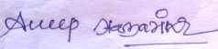
Dr. Anup Hazarika
HoD., Anthropology Department
North Gauhati College.

